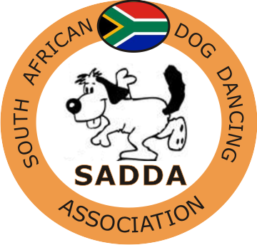 |  |  |  |  | South African Dog Dancing Association  COMPETITION ENTRY FORM
Title |  |  |  |  |  | Name |  |  |  |  | Surname
Postal Address |  |  |  |  |  |  |  |  |  |  | SADDA No
 |  |  |  |  |  |  |  |  |  |  | Telephone No
 |  |  |  |  |  |  |  |  |  |  | Fax No
Post Code |  |  |  |  |  |  |  |  |  |  | Email address
Name of hosting  Club |  |  |  |  |  |  |  |  |  |  |  | Date of Competition
Level of Team |  |  |  | Class Category Entered |  |  |  |  |  | Dog’s Name |  |  | SAWDA No |  |  |  |  |  |  |  |  |  |  |  |  |  |  |  |  |  |  |  |  |  |  | HTM or MF |  |  |  | Fee
Music Chosen |  |  |  |  |  |  |  |  |  |  |  |  | AGE OF DOG (at date of show)
Music Chosen |  |  |  |  |  |  |  |  |  |  |  |  | AGE OF DOG (at date of show)
INDEMNITY : All SADDA events are run and managed according to the Rules and Guidelines of SADDA. All competitors entering do at their own risk, and neither SADDA or the hosting club will be held responsible for any loss, damage, injury or theft which might be incurred during the process of the competition. Dogs need to be contained and under control at all times during the course of the competition. |  |  |  |  |  |  |  |  |  |  |  |  |  |  |  |  |  |  |  |  |  |  |  |  |  |  |  |  |  |  |  |  |  | Total Entry Fees:
Declaration |  | I undertake to abide by the SADDA Rules, and have read and understand the Indemnity
by Entrant: |  | Signature: |  |  |  |  |  |  |  |  |  |  |  |  |  |  |  |  |  |  |  |  | Date:

